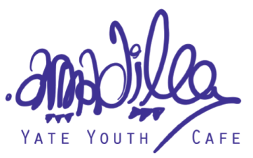

The Armadillo - How are we minimising risk?

Please stay at home if you have COVID19 symptoms, or have had contact with symptoms in the last 14 days.

The Youth Entrance will be the main entrance at the front of the building, exit/ pick up via the rear gate (into rear car park)

We ask that you help us to keep you safe by:
- Providing your contact details for “Test and Trace”

- If you are 11year+ please wear a face covering over your nose and mouth at all times inside the building;
- Maintain social distancing always;
- Wash or sanitize your hands when you arrive at the Armadillo, before using the toilets, and whenever advised by staff;
- Comply with staff directions for movement around the building:
- Take your litter home with you.

We take health and safety very seriously and we have taken several measures today, to reduce the risk of COVID19 contamination.

We have:
- Cleaned our premises thoroughly before and after every activity;
- Worn PPE where appropriate:
- Washed and sanitized our hands regularly and provided visitors with facilities to do so;
- Ventilated the building;
- Kept all areas clean, tidy and free from litter;
- Signposted clear access routes including entrances and exits;
- Limited the number of people and staff in each area of the building and activity;

- Planned workshops in a way that maintains social distancing;
- Ensured equipment is cleaned thoroughly and/ or provided new equipment for each visitor;
- Staggered workshop spaces and times.

If we feel that you are not complying with our COVID19 policy, we may ask you to leave the Armadillo.

While we strive to make every reasonable effort to keep you safe, we do not accept liability for any case of COVID19 which may occur from contamination in our building and activities, in spite of our very best efforts to keep you safe.
