
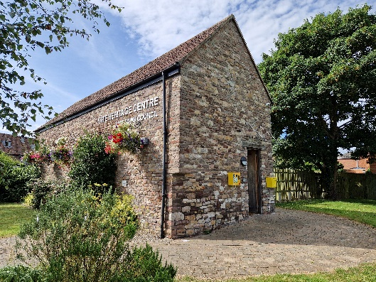
Yate Heritage Centre Volunteer Application Form

Yate Heritage Centre, Church Road, Yate BS37 5BG 01454 862200
Thank you for your interest in becoming a volunteer at Yate Heritage Centre – we are delighted that you would like to join our team!

Our service is only possible because of the support we receive from our wonderful volunteers. We ask volunteers to commit to weekly shifts as much as possible, and for all volunteers to commit to at least x2 shifts per month, to ensure our services can remain open to the public.

Please complete the following form and return to us via:

Email: vacancies@yatetowncouncil.gov.uk
Post: Yate Town Council, Poole Court, Poole Court Drive, Yate BS37 5PP

- - - - - - - - - - - - - - - - - - - - - - - - - - - - - - - - - - - - - - - - - - - - - - - - - - - - - - - - - - - - - -

Section 1. Personal Details

Title
Full Name
Date of Birth
Address
Telephone
Email

Section 2. Occupation and Voluntary Experience

Occupation (past / present and any other relevant work experience:

Voluntary experience:

Section 3. Further Information

Skills and interest:

Are you currently doing voluntary work with any other organisation?

☐ Yes ☐ No

If yes, please list organisations:

Do you have any physical restrictions / additional needs?

☐ Yes ☐ No

If yes, please state:

Section 4. Volunteering Availability

Days | Morning Shift | I am available | Afternoon Shifts | I am available
Tuesday | 9.45am – 12.45pm |  | 12.45pm – 4.15pm
Wednesday | 9.45am – 12.45pm |  | 12.45pm – 4.15pm
Thursday | 9.45am – 12.45pm |  | 12.45pm – 4.15pm
Saturday | 9.45am – 12.45pm |  | 12.45pm – 3.15pm

I understand that the information contained in this application may be retained by Yate Town Council in line with GDPR and Yate Town Council Data Management Policy for the purposes of administering the Volunteer Scheme. Yate Town Council will not share this data with any third parties without notifying me.

Signed …………………………………………. Dated …………………………………

